Glare
Glare is an important daylight consideration for any space in a building, especially when daylight is being used as the primary light source for that area. Glare is often found in spaces where light is directly hitting an occupant’s eyes or reflecting off a specular material. Using FusionOptix, photos of 10 spaces were taken using both the luminance mode and normal photo mode to compare the perceived glare and luminance of a space. The scale was locked to 25 ISO and 1/2000 shutter speed, resulting in a range from 229 cd/m^2 to 1835 cd/m^2 to ensure the luminance’s across different spaces and days could be compared easily.

An interesting comparison I ran to understand the effects of glare in a space was to compare the area of my bedroom by my desk which has an east facing window behind a tree. Comparing the space with blinds up, open, and closed provide good insight into what can potentially cause glare. Looking at the three images, the blinds down but angled open is the most comfortable space to be in which is caused by the diffusion of light throughout the space. When the blinds are closed, the space is too dark and requires electric lighting and with the blinds up, the sun streams into the space in one direction, not evenly illuminating the space. With the blinds open, a lot of the light is redirected back up to the ceiling or to the wall, creating a more even glow of illuminance in the space, which is clearly visible in the pseudo color image. This diffusion of light creates less contrast between the window and the rest of the space, allowing for the eye to work less to adapt between the two surfaces and creating a better experience. I believe that the contrast between the surfaces (window and wall) in a space along with the intensity of the daylight contributes to the perception of glare in the space.

The rest of the images can be found in the appendix.

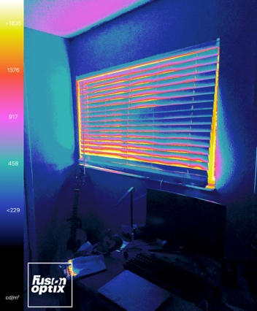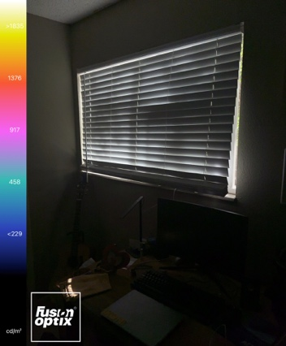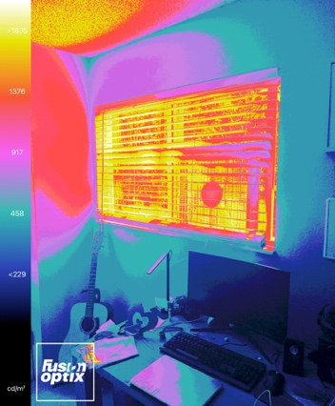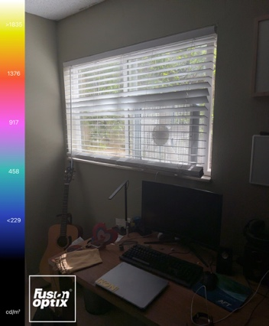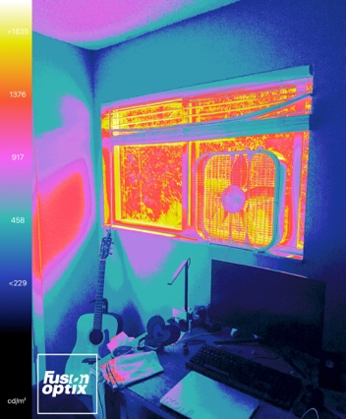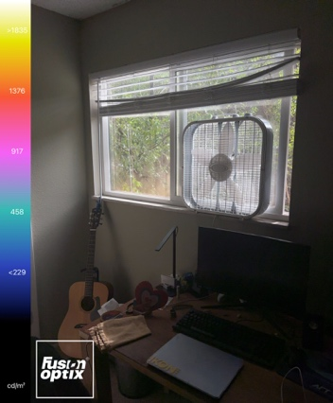
Blinds Up
Blinds Open
Blinds Closed

Mathematically, DGP can be quantified using a few simple metrics. Generally speaking, the luminance and size of the source are proportional to the probability that someone in the space will experience glare. The illuminance vertically at the eye and the position of the source from the eye are inversely proportional to DGP. The roughly works out to the simple idea that higher contrast between the source and amount of light at the eye leads to higher glare probability likely because the eyes muscles cannot adjust well enough and are in a state of constant use, creating muscular and neurological discomfort. It is hard to always quantify these metrics as everyone’s eyes work differently, but it is a wonderful place to start and should be considered when building with daylit spaces.

Parametric Design
Parametric design is a great way to analyze many different design ideas in a short amount of time. For this project, iteration through louver design was the most logical choice. Using the basis of Reinhardt’s code to control create and control the louvers, I implemented a vertical set of louver testing as well to see if there was a large different between horizontal and vertical.

The grasshopper file works in a few different sections. First a room is created using basic honeybee commands that creates a room and window. The window wall ration on the south wall is controlled by a slider that dynamically changes the size. Next the geometry of the window is read, points from the edge are found, and sets of points are drawn between the corners. The number of points between the edges is controlled using a slider as well. Lines drawn between opposite points create the basis for fins, which then can be extended out a certain distance, controlled by a slider for louver depth.

With the louver drawn, the analysis of daylight can be run on the space using grid points and run through different honeybee object to extract the daylight information we want. This caused some problems as the glare plugin seems to be updated incorrectly right now, which is unfortunate because those metrics would have been interesting to analyze as well.

Lastly, there is a colibri setup that iterates through the desired louver depths, number of louvers, and window wall ration to test every scenario. 8 layouts for both the vertical and horizontal louvers were run with two louvers depths, two louver amounts, and two window wall ratios. Initially these values were higher, but due to the time it takes to run each simulation, the number of options were reduced for time consideration. Unfortunate one run from each test failed to collect data for an unknown reason.

The next step would be incorporating the annual glare metrics and measuring DGP from renders taken inside each of the runs. These were not implemented due to complexity and time as they would likely require a full redo of the code from scratch as Reinhards code was set up differently than I would have set it up.

Below is the data collected from the results. A consistent trend emerges with the WWR; the smaller WWR ratio results in a significantly low Daylight Autonomy regardless of the louver layout has a higher percentage of the Useful Daylight Index in the “to low” section. The horizontal louver layout suffers more than the vertical louvers, likely due to the cutting off of midday sun during the warmer months. The only benefit to the smaller WWR is a very low time spent with too much light in the space, UDI high.

The vertical louvers perform better in almost every category except having marginally more time in the UDI high category. I think this is common in more northern climates as summer sun can be adequately blocked most times of the day except when parallel to the louvers, while horizontal louvers harshly cutoff the light during the summer but fail to do much during the winter.
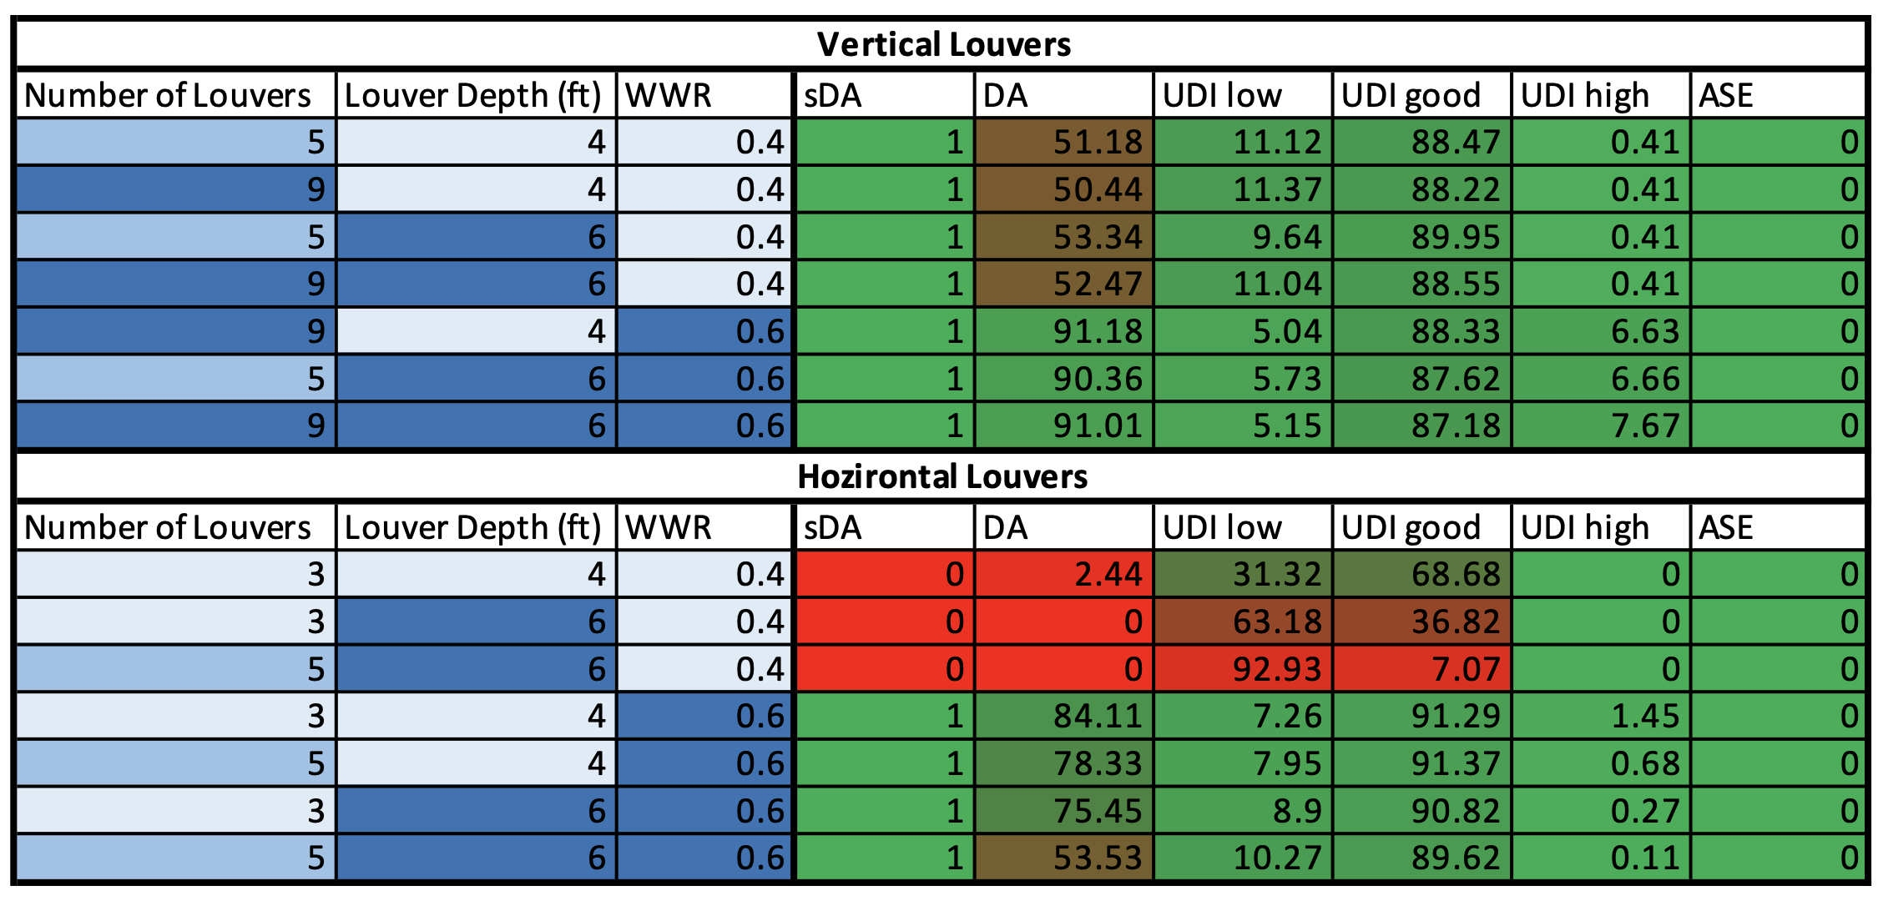

I like vertical louvers as a daylighting solution because I think they allow more design options and can be utilized to create interesting facades along buildings. According to the data collected here, they outperform horizontal louvers in most categories and balance blocking harsh daylight and allowing occupants to benefit from daylight hitting the space.

The parametric design process was fun, and I enjoyed finally learning grasshopper more thoroughly. The process, while a bit tedious at times due to how long it could take to run, allows quick iteration of ideas and data collection. I would have loved to implement more into my report but unfortunately with ASCE conference and being under the weather, it didn’t happen. The next steps would be to add the annual glare metrics, pull renders for DGP analysis, and then begin iterating with the angles of the fins to determine the best angle for a southern façade. Lastly, it would have been interesting to implement the shifting of fin design with a boolean line or other form shaper to create more organic shapes in the fins.

Appendix:
Top to Bottom, Left to Right:
4th floor office tower bar, my bedroom (blinds closed)
My bedroom (blinds open), my bedroom (no blinds)
Lighting lab, 4th floor hoteling room
ITLL (from second floor), MechE wing Tables
EC basement hallway, ECCR hallway

